Project Design Phase
Problem – Solution Fit Template

Date
Team id | NM2025TMID02994
Project Name | LEASE MANAGEMENT
Maximum mark

Problem – Solution Fit Template:
Problem:
Businesses and property managers struggle to manage multiple leases using manual methods like spreadsheets and paper files. This leads to missed payments, renewal delays, compliance issues, and poor visibility of lease data.
Solution:
An automated lease management system that centralizes lease information, sends alerts for key dates, ensures regulatory compliance, and provides real-time reporting and analytics for better decision-making.
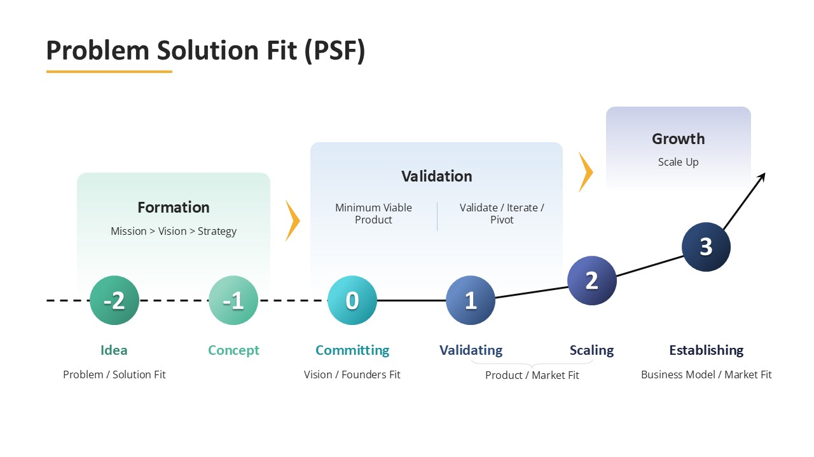

This project addresses a critical issue in lease and data management systems. It ensures that no active lease linked to a tenant or property can be accidentally deleted. This improves data integrity, accountability, and operational transparency in lease management workflows. The solution uses rule-based checks and continuous monitoring to safeguard records and maintain compliance. Implemented in platforms like ServiceNow or lease management software, it supports secure, reliable, and compliant lease administration.

